CHINGOLA DISTRICT COMMMON EXAMINATION
Examination for the School Certificate (Grade 9) End of term 1- 2022

Design and Technology 6048/1
Theory and design Paper 1

Candidate Name________________________________________________

Candidates Name: …………………………………………………………………………… 155 Marks
Time: 2 hours 30 minutes
No Reading Time
Instructions to Candidates
- Write your name on the space provided for you on the cover page
- There are three (3) sections in this question paper, section A, B and C.
- Answer all the questions in this section A, and B on spaces provided,
- There are three parts in section C; part I, II and III. Questions 32 is compulsory, answer one question in each part.
- Write your answers in the space provided on the question paper

SECTION A [30]
Multiple choice answer Grid.
1 |  |  |  | 2 |  |  |  | 3
A | B | C | D | A | B | C | D | A | B | C | D
4 |  |  |  | 5 |  |  |  | 6
A | B | C | D | A | B | C | D | A | B | C | D
7 |  |  |  | 8 |  |  |  | 9
A | B | C | D | A | B | C | D | A | B | C | D
10 |  |  |  | 11 |  |  |  | 12
A | B | C | D | A | B | C | D | A | B | C | D
13 |  |  |  | 14 |  |  |  | 15
A | B | C | D | A | B | C | D | A | B | C | D
16 |  |  |  | 17 |  |  |  | 18
A | B | C | D | A | B | C | D | A | B | C | D
19 |  |  |  | 20 |  |  |  | 21
A | B | C | D | A | B | C | D | A | B | C | D
22 |  |  |  | 23 |  |  |  | 24
A | B | C | D | A | B | C | D | A | B | C | D
25 |  |  |  | 26 |  |  |  | 27
A | B | C | D | A | B | C | D | A | B | C | D
28 |  |  |  | 29 |  |  |  | 30
A | B | C | D | A | B | C | D | A | B | C | D

SECTION A [30]
Multiple choice questions
Answer all questions. Mark your answers with a cross (X) on the answer Grid provided in the answer booklet.
- Mary was cutting by a piece of wood in the workshop. Suddenly, a piece of wood got into her eye. What would you do?
  - Clean the eye with water.
  - Cover her eyes with a wet cloth.
  - Report the matter to the teacher.
  - Take her to the clinic.

- When steel is coated with zinc to prevent rusting, it is said to have been
  - Alloyed.
  - Galvanized
  - Soldered.
  - Tempered.

- A design and technology teacher asked his pupils to define some plain figures. Which of the following statements describes a Hexagon?
  - Four sided figure.
  - Eight sided figure
  - Six sided figure
  - Three sided figure.

- Which of the following timber is classified as softwood?
  - Mukwa. B. Elm. C. Pine. D. Teak

- In Zambia distribution system of electricity, the neutral wire is represented by ……
  - Blue. B. Red. C. Black. D. Yellow.

- The following lines meet at 90° except……
  - Center lines.
  - Perpendiculars
  - Radius.
  - Tangents.

- What stage should the systematic investigation to establish the facts to be considered during the design process?
  - Analysis
  - Design brief.
  - Specification.
  - Research.
- The other name for bench clamp is …………..
  - Mitre box.
  - Bench stop.
  - Bench vice.
  - Bench hook.

- The following are manufactured boards, except ………….
  - Block board.
  - Chip board.
  - Urea formaldehyde.
  - Medium density fibre board.

- When a material can be stretched and be drawn into wire, it is said to be …….
  - Tough.
  - Ductile.
  - Malleable.
  - Brittle.

- The removal of excess moisture from timber is called ………..
  - Conversion
  - Felling
  - Seasoning
  - Sawing

- What is the name of the line indicated by the latter X as shown in the figure 1
below?
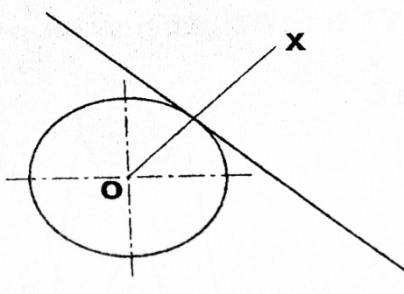
Fig. 1
  - Tangent. B. Diameter. C. Normal. D. Perpendicular.

- A state of being out of harm or danger …
  - Safety signs.
  - Protective.
  - First aid.
  - Safety.
- Which one of these is not a component of design and technology?
  - System technology.
  - Manufacturing materials.
  - Needle work.
  - Graphic communication.

- Bronze is an alloy of copper and ………..
  - Lead. B. Zinc. C. Tin. D. Iron.

- ……………. are used for both cooling and heating depending on the air properties at a given time.
  - Vents.
  - Air extractors.
  - Fans.
  - Air conditioners.

- The drawing in figure 2 shows a tool used on the bench. study the drawing and refer to it when answering questions 17 and 18.
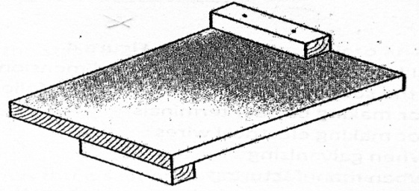
Figure 2
  - Bench well.
  - Bench hook.
  - Chopping board.
  - Bench stop.

- What is the use of the tool?
  - Chopping pieces on.
  - Glue parts on.
  - Supporting wood when cutting at 45.
  - Supporting work while sawing.

- When a formed thermoplastic is reheated, it returns to it’s original shape. This is
called ………….…………….
  - Deformation.
  - Elasticity.
  - Formation.
  - Plastics memory.

- At what stage of the design process, do you estimate the cost of the product?
  - Design brief.
  - Specification.
  - Possible solutions.
  - Evaluation.

- Plastics can be categorized into two groups, namely ………….
  - Ferrous and non-ferrous.
  - Thermo setting and a petroleum jelly.
  - Petroleum and thermoplastics.
  - Thermoplastic and thermosetting.

- The diagram below is showing two materials. One is made of wood and the other of acrylic plastic.
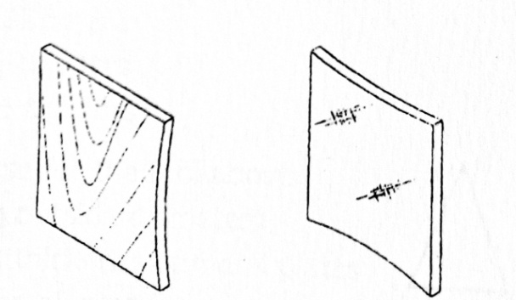
Figure 3

Name one type of glue that would be used to laminate them.
  - Polyvinyl Acetate (PVA)
  - Animal glue
  - Varnish
  - Contact glue

- What is the best finish to apply on artifact that is made of mild steel which will outdoor?
  - Oil B. Varnish C. Gloss paint D. Water paint

- Most handles of cooking utensils are made of thermosetting plastics because it ………
  - Is a poor conductor of heat and electricity
  - Is hard, strong and easy to handle.
  - Resists corrosion and can easily be reshaped.
  - Resists rust and it is colorful.
- If your friend is injured in the workshop and he is bleeding, you should quickly ………
  - Report to the teacher.
  - Stop the bleeding.
  - Take him to the clinic.
  - Wash the wound.

- In graphic communications, a pair of dividers is used for…….
  - Dividing a line into equal parts.
  - Dividing the angles into equal parts.
  - Transferring measurements from the drawing to the rule.
  - Transferring measurements from the rule to the drawing

- Another name for a bench hook is …………
  - Sawing board
  - Bench stop.
  - Mitre box.
  - Bench hold fast.

- Which of the labeled parts represents a chord?
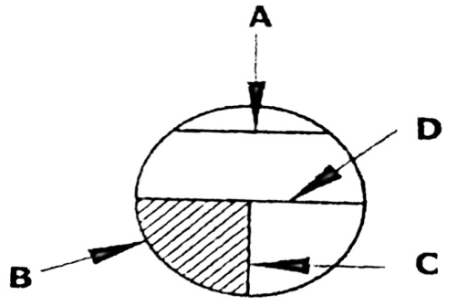

Figure 4

- Which method would you use to improve the appearance of a drawing to make it more realistic?
  - Line shading
  - Punching
  - Rendering
  - Tone shading.

- Aluminum is used for making aeroplane bodies because it ………..
  - Cannot conduct electricity.
  - Is light in weight
  - Cannot conduct heat.
  - Has a good surface finish
SECTION B [30 marks]
Answer all questions in the spaces provided in the answer booklet.
- a) i. Name the correct materials used in making the following products.
Aircraft body [1]
Water pipes [1]
Musical instruments [1]
ii. The drawing in figure 8 shows a garden tool.
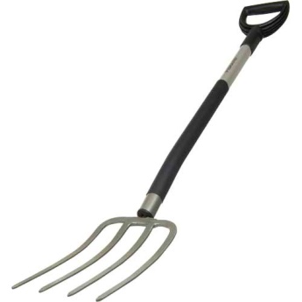
Figure 5
- Name a suitable material that can be used to make a garden tool. [1]
- Give one property of the material you have mentioned in a (ii) [1]
- What is the difference between thermosetting plastic and thermoplastic [2]

- What do you understand by the term plastic memory [1]

b) The shape of the key holder is marked out as shown in figure 6.
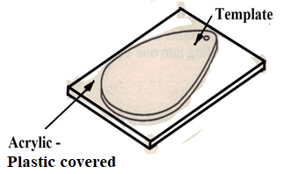

Fig. 6

- What would you use to mark out the shape of the key holder? [1]
- Give a reason for your answer in (e), (i) above. [1]
- What abrasive should be used to smoothen the edges of the key holder [1]

c) Figure 7 shows a cross section of a tree. Study it and answer the questions.

D
B

A

C
E

Fig. 7

i Label the parts marked A, B and E [3]
ii. State the function of the parts labelled C and D [2]
iii. There are three elements that need to be in place for fire to take place;
State one of the three elements of fire. [1]
iv. List three items found in the first aid box. [3]
(d) Figure 7 below shows a tool that is used in Bricklaying
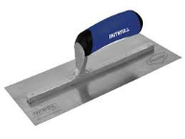
Fig. 8
- Name the tool in figure 7. [1]
- State two materials that are aggregates [2]

e) The drawing in figure 8 below shows an electric circuit in symbols.
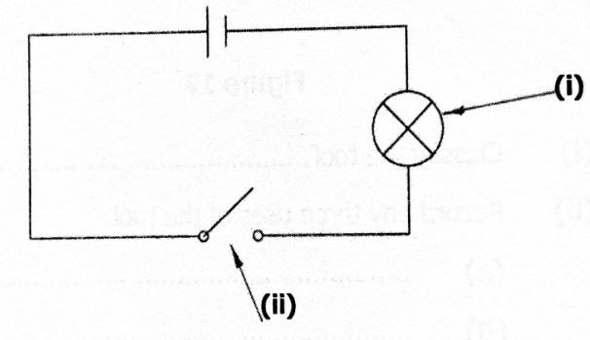
fig. 9

- Label the components marked (i) and (ii) [2]
- If the circuit has the current of 2A and the P.d of 6V, calculate its resistance. [2]
- State the instrument used to measure
Resistance [1]
Voltage [1]
Current [1]
[Total: 30 marks]

SECTION C [95 marks]
There are three parts in this section part I, II, and III. Part I is compulsory.
Answer one question from part I and one question from part iii
Part I
Questions 32 on part I is Compulsory
- The following situation is obtaining regarding cooking utensils in your kitchen.

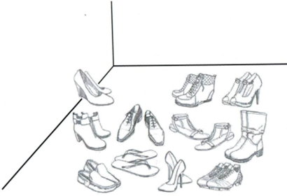

Figure 10

- (i) Suggest a problem from the given situation. [2]
(ii) From the problem suggested in a (i) above, write a design brief [3]

- From the design brief suggested, one of the specification to be considered.
- Indicate any other four (4) specifications to be considered. [4]
- Sketch one possible solution you may consider. [10]
- What safety measures did you consider to make the possible
solution in (b)(ii) safe for use ? [2]
- (i) Suggest any two types of materials you would use for your possible
solution. [2]
(ii) Give two reasons for your choice of material. [2]
[Total: 25mark]
Part II Choose one question
- Either (a) or (b)
- The home Economic Department would like the Design and Technology
section to make some tea trays for them.

- Complete the cutting list that your teacher has started for you.
Part | Qty | L | w | H | Material
Side rails |  | 500mm
 |  |  |  |  | Pine wood
Base | 1 |  |  | 18mm
[12]

- Explain what is involved in the following stages of material preparation and the tools used.
- Measuring [2]
- Marking out [2]

- Sketch a free hand pictorial drawing of the tea tray. The sketch must be of good proportion, neat and include rendering. [5]

- Name a finish that could be applied on the tray and give the reasons for choosing that finish. [4]

[Total: 25 marks]
- (i) The drawing in figure 11 shows a garden tap

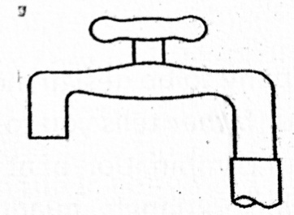
Fig. 11

- Name one specific suitable materials that can be used to make a garden tap. [2]
- Give two properties of the material you have mentioned in b (1). [2]
- List two examples of thermoplastics and thermosets. [4]
- Suggest the best ways of disposing off plastics. [2]

ii. Figure below shows a tool used in the design and technology workshop
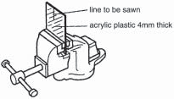
Fig, 12

- Name the tool [2]
- State the function of the named tool above [2]
- Name any marking out tool used to produce curves on plastics [1]
- Draw a cutting tool to use when cutting a 4mm thick acrylic plastic. [5]
- List (2) two types of sanding materials. [2]
- Give three effects of plastic on the environment. [3]

[Total: 25 marks]

Part III
Graphic communication – Choose one question from 34 and 35
- A Design and technology pupil was told by the teacher to come up with designs of
making a tennis trophy for the school championships. ABC is a semi-ellipse. Draw the
tennis trophy full size showing all construction lines.
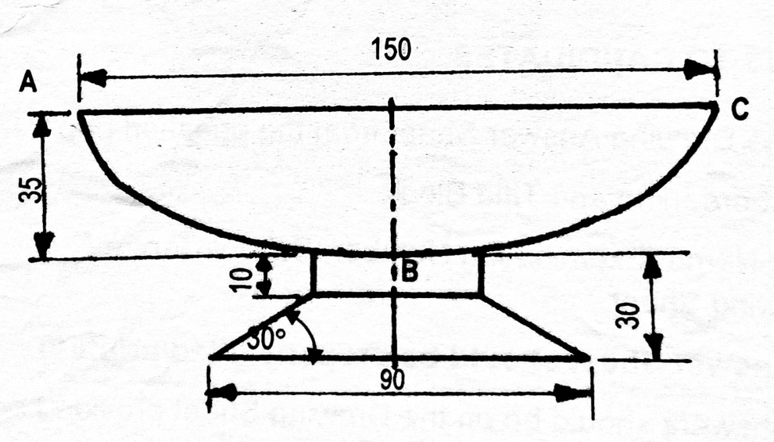
Fig. 12
[Total: 30 marks]

35 A new school has been built in Munani Community called Bwali Technical
School , and you being a student of Design and Technology has been asked
to Design a log of this school given data:
- Triangle ABC which has the following measurements:
- AB=100mm
- AC=BC=80mm

a). Construct the given triangle
b). Inscribe a circle in triangle ABC.
c). Circumscribe a circle to triangle ABC.
d). Measure and state the diameter for the circumscribed circle.
e) Print the name of the school on the segment below the triangle

[Total: 30 marks]

